|  |  |  |  |
| --- | --- | --- | --- |
| Lab No. | Manual | Week | Marks |
| 6 | To develop a Branch Information System with all details such as school, course, branch. Here all subjects and their code details should be arranged according to semester. All details should be arranged in table format. Use Combo box for branch selection and Button for Event generation. | Week 5 | 10 |

**LAB-6**

**Objective:** To develop a Branch Information System with all details such as school, course, branch. Here all subjects and their code details should be arranged according to semester. All details should be arranged in table format. Use Combo box for branch selection and Button for Event generation.

**Prerequisite:** basic Html, CSS, JavaScript

Skilled Developed: How to design an application at client side and perform events with client application.

**Description**

This Program is use to help those student who is going to take admission in the respective department. Branch Information System is also helpful for that student who has taken admission to the respective department.

This information system contains the details of all school and the courses which is offered by the school. All the courses contain the semester and the subject code with its instructor details.

**Expected input**

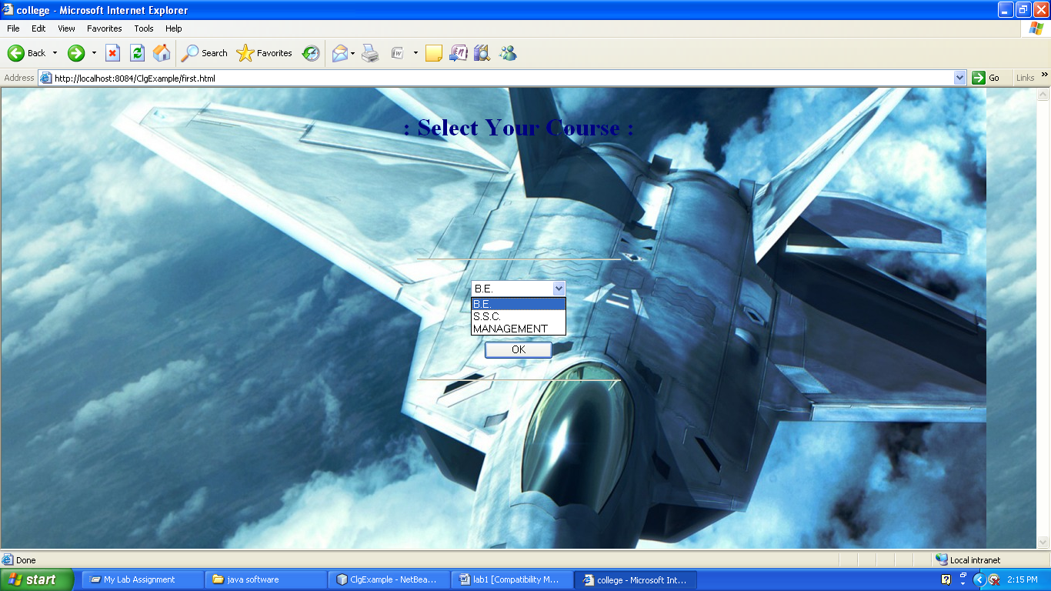

**Expected output**

